Speed Test

1. Define

* Calculator the speed of every page in website
* Uses : check and compare speed of each page in website

1. Property

3 kinds :

Page interactive time : how long it takes to become usable

Page load time : how long it needs to load completely.

1. Apply

* Input : Link(href) of all pages
* Output : Time of each pages => average
* Tool : selenium, phantomjs
* Selenium : support to get link
* Phantomsjs : support to headless testing(not open browser)
* Built with Maven project

1. Another concept
2. Resource

Declare Selenium in project

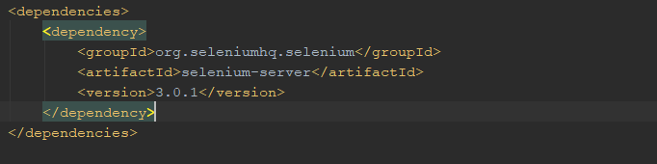

<http://phantomjs.org/download.html>

Declare webdriver with phantomjs in project



6. Question

- How to simulated bandwidth – for example, 3G or 4G for mobile?

- How to test all in the same time ? (Test NG?)